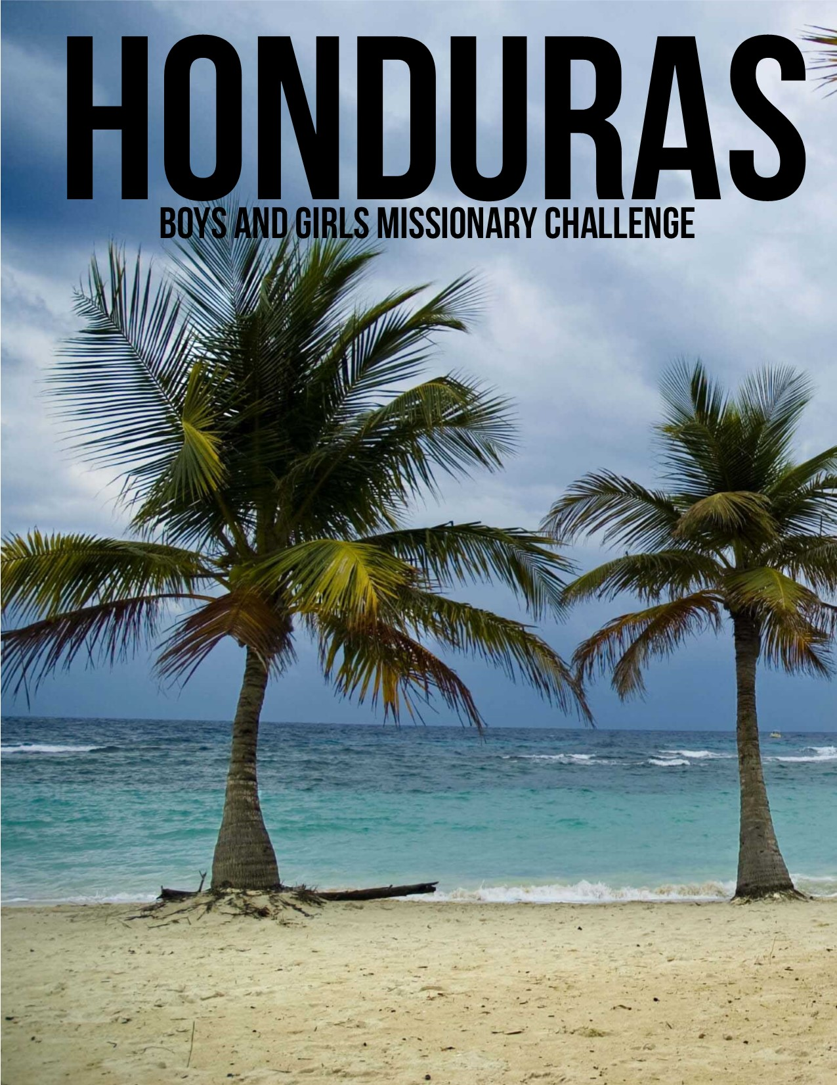

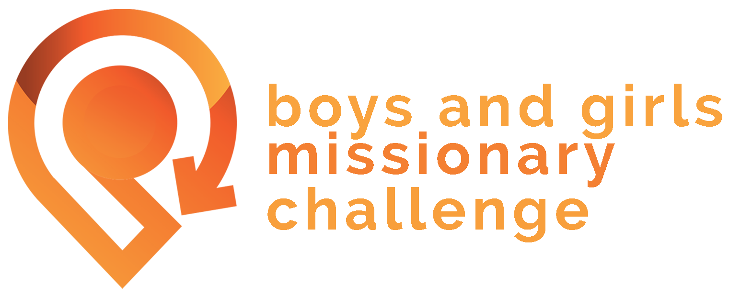

This Project Guide is to help lead us in prayer for the people of Argentina and our missionary, Brooke Miller.
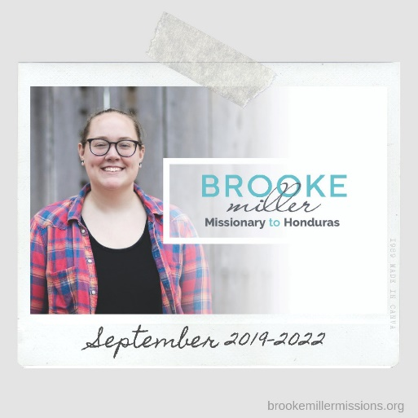

These Boys and Girls Missionary Challenge Project Guides are created to present an opportunity to partner with a specific missionary, via designated giving, culturally specific prayer, and similar serving opportunities to the featured missionary. Use this Project Guide on a regular basis to bring missions to life by developing a heart of generosity in your kids’ ministry! Our hope is that you will use this simple tool to teach your kids about evangelism, both in the global and local context. For your convenience, we have included a link so you can download all media for this Project Guide. See link below (case sensitive).
http://bit.ly/BGMCMillerMedia

GPS – Give Pray Serve
BGMC exists to help kids give, pray, and go (GPS) with missionaries around the world. One of the ways a heart of generosity can be measured is through a few actionable items: how are the kids in your ministry giving? How are they praying? How are they serving? We want to measure the effectiveness of a child’s missional heart through their own desire to give, their own desire to pray, and their own desire to serve. You are leading kids in prayer for children in other parts of the world. God is calling many of them to go across cultures and tell people about Jesus. Consider giving toward those who are ministering to the unreached corners of the Earth. A giving form is attached at the end of this Project Guide and we hope that you consider contributing toward this excellent ministry. The Project Fundraising Goal is $10,000; once that goal is met, remaining funds will be donated towards critical needs – such as food, Bibles, water, clothes, medicine, shelter – for missionaries on the field. Donations to the critical needs fund may be made at any time throughout the year.
As your commitment is an agreement between you and God, it is understood that you may revise it at any time. Once a need is met, we reserve the privilege of redirecting funds to the BGMC Critical Needs Account. If the pledged amount is not met, BGMC reserves the right to redirect the church or district’s undesignated funds.
Project Fundraising Goal: $10,000

PART 1 – The Hondurans
The republic of Honduras is a country located in Central America. It is the second largest country in Central America and the only one that is bordered by four other Central America countries. It has a long coastline with beaches and islands. Honduras is a tropical climate covered with rainforests and mountains. There are two seasons in Honduras – rainy season and dry season. It is extremely hot during both seasons!!!! With 22 different people groups, there are over 8 million people that live in Honduras. There are 10 different languages spoken but their official language is Spanish. Soccer is their main sport.
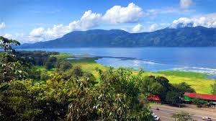

- PRAYER POINT: There are several people groups in Honduras that are still considered “unreached”. Pray that God continues to call Hondurans to minister to and plant churches in these unreached people groups.

PART 2 – Introducing BROOKE MILLER
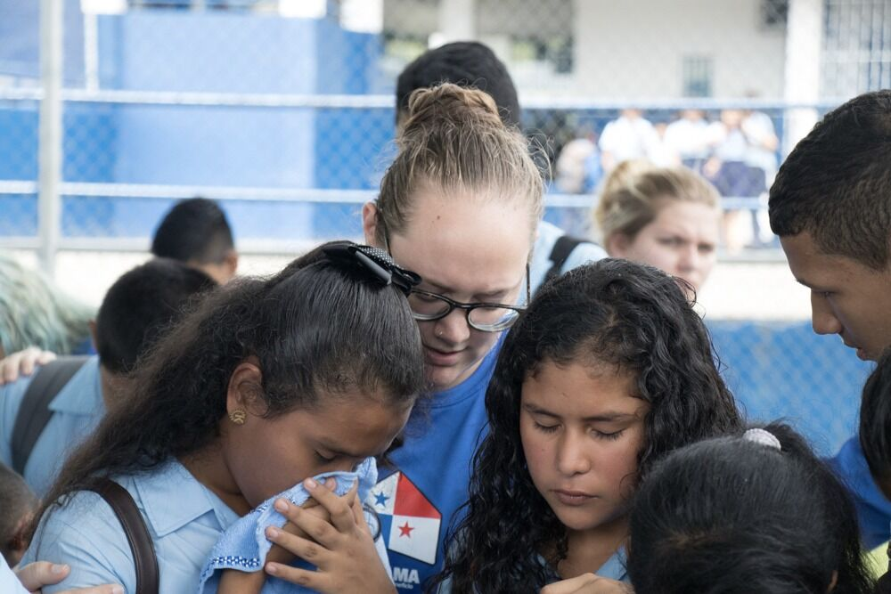
Brooke Miller is a missionary to the people of Honduras. She grew up in Indiana and felt God leading her to missions when she was just 16 years old. It wasn’t long before she felt the Lord leading her to serve in Latin America working with kids. So, when she was 18 years old, she moved to Latin America and began her life as a missionary. In Honduras, she gets to teach kids about Jesus by doing camps and VBS in different communities. A lot of churches in Honduras do not have the training or resources to have kid’s church like we do in the US. So part of her job is helping to train other people and their churches to minister to kids.
- PRAYER POINT: Pray for even more partnership between the church and missionaries as we work together to reach kids throughout the country.

PART 3 – life in HONDURAS
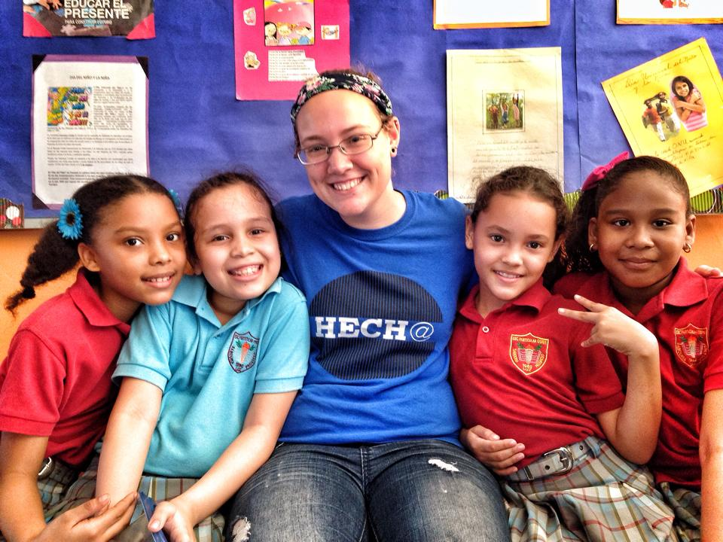
Kids in Honduras are much like kids in the U.S. They love to play games with the neighborhood kids every chance they can get. You will often find pick-up games of soccer or kids playing marbles in the streets. If they have a tv, they love to watch soccer on tv too!
The national food of Honduras is called a baleada. It’s like a quesadilla filled with eggs, queso and beans. It’s a cheap food you can find on just about every street corner.

- PRAYER POINT: Pray for creative solutions and ideas to minister to kids in new ways.

PART 4 – many religious backgrounds
The majority of Hondurans consider themselves to be Catholic but are non-practicing, meaning they do not attend or interact with the Catholic church at all. This can make it difficult share the Gospel with Hondurans because many people will say they are “Christians” because their parents or grandparents belong to the Catholic church. Catholicism is similar to our Christianity but they pray to many idols and believe they must earn the grace that God freely offers us. Because many of these Catholics consider themselves Christians they often do not see a need to change and are reluctant to listen.
There are also different religions among some unreached people groups throughout the country. These religions are considered to be part of the occult and are steeped in the mystical and supernatural.

- PRAYER POINT: Pray for open doors to minister to all people groups and wisdom in conversations with Catholics.

PART 5 – needs of the church
Honduras has a huge problem in their major cities. Gangs run the cities and many kids are directly affected. Right now the Church in Honduras sees children’s ministry as the major need. The Church has been asking for more missionaries to help by providing training for their churches and to have more outreaches in the surrounding areas.
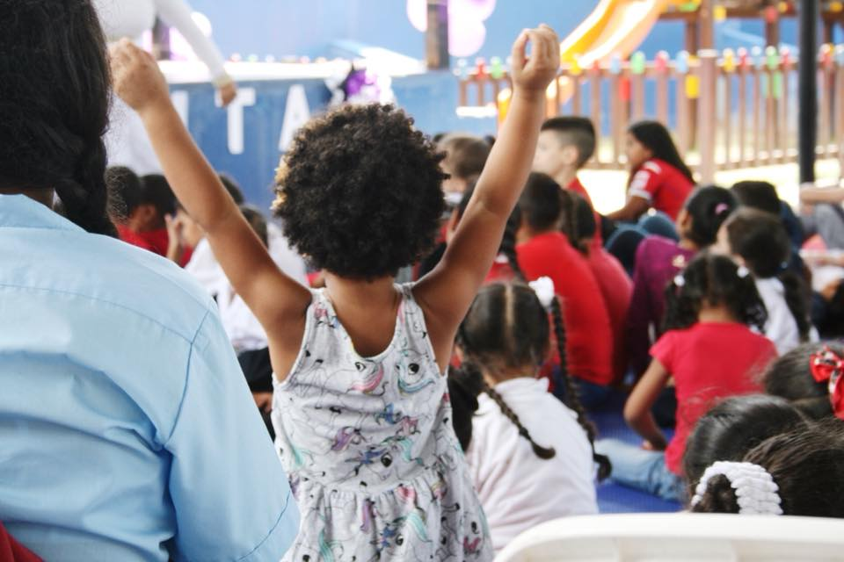
The other major need in Honduras is church planting. Other missionaries and myself work together to plant new churches in rural communities that would otherwise have to walk for miles and miles to encounter a church and in villages that have never had access to a church.
- PRAYER POINT: Pray for even more missionaries to come to Honduras to help us reach the children for Christ.

PART 6 – The PROJECT
Children’s ministry is the number one need in Honduras right now. This BGMC project will help Brooke in providing resources to churches that has no children’s ministry. Monies raised will allow her to do children’s evangelism events in the communities that need it most. Generous giving will help her to be able to purchase kits filled with kid’s church supplies, curriculum, sound equipment, Bibles and more to train and evangelize.

- PRAYER POINT: Pray the missionaries will have all the supplies they need to be able to evangelize in their community.

PART 7 – Ministry opportunities
In San Pedro Sula, where Brooke lives, many kids have nowhere to go after school and are unsupervised for hours. Many end up failing in school and/or falling into the wrong crowd after spending most afternoons in the street with other kids. This creates a unique opportunity to create a before and after school center for kids to receive tutoring and homework help and keep them off the streets. In partnership with a church, Brooke also works in an after school center to provide a place for elementary students to get the help they need to stay in school and out of trouble.

- PRAYER POINT: Pray for strong relationships to be built with the children that attend the after school center and their families.
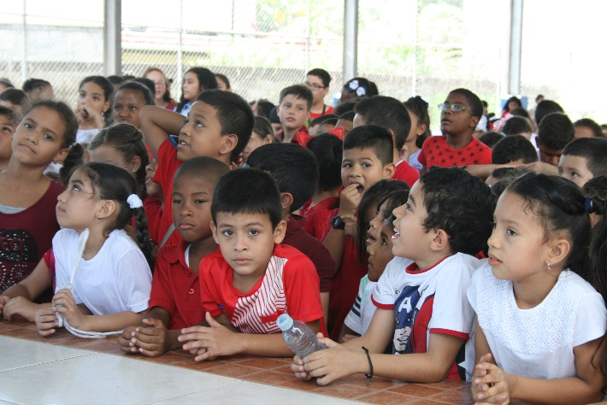
Donor Acct __________________________ Church Name ________________________
Donor Name_________________________ Church City __________________________
Phone ______________________________ Church Account ______________________
Address _______________________________________________________________________
City ________________________________ State ______________ Zip ________________ Email ________________________________
Make checks payable to: Online giving:
BGMC http://bit.ly/BGMCMillerGive
1445 N Boonville Ave. Online Giving Code: 920154-2
Springfield MO 65802

Special Target: 007-002 920154-2

BGMC Missionary – Brooke Miller http://bit.ly/BGMCMillerGive
Special Project: Church Plant Resources and CM Evangelism
Special Project Goal: $10,000
Amount Enclosed $_______________

